OSPREY AND FIREBALL CLASS OPEN MEETING
AND SOUTHERN AREA CHAMPIONSHIP

Saturday 29th May and Sunday 30th May 2021
Organising Authority - Poole Yacht Club
Poole Harbour, UK
Notice of Race (NOR)
 | The notation ‘[NP]’ in a rule means that a boat may not protest another boat for breaking that rule. This changes RRS 60.1(a).
1 | RULES
1.1 | The event is governed by the rules as defined in The Racing Rules of Sailing.
1.2 | The Rules of the Osprey Class Association, available at https://ospreysailing.org.uk/ applies.  The Rules of the Fireball Class Association, available at https://www.fireballsailing.org.uk/images/generalcontent/International%20Fireball%20Rules%20FIR2021CR20210309-27126.pdf applies.  This Notice of Race, available at https://www.pooleyc.co.uk/ applies.  The Sailing Instructions for this event, available at https://www.pooleyc.co.uk/ applies.  Poole Harbour Sail Racing Procedures (formerly Yacht Racing Criteria) , available at https://www.phc.co.uk/wp-content/uploads/2020/08/Poole-Harbour-Sail-Racing-Procedures-V.8-Aug-2020.pdf, applies.
1.3 | [NP] COVID Statement By taking part in any of the events covered by this notice of race, each competitor agrees and acknowledges that they are responsible for complying with any regulations in force from time to time in respect of COVID-19 and for complying with the Poole Yacht Club COVID-19 procedures. Competitors and support persons shall comply with any reasonable request from an event official. Failure to comply may be misconduct. Reasonable actions by event officials to implement COVID-19 guidance, protocols or legislation, even if they later prove to have been unnecessary, are not improper actions or omissions.
2 | SAILING INSTRUCTIONS
2.1 | The sailing instructions will be available after 09.00 on 24.5.2021 at https://www.pooleyc.co.uk/
2.2 | The Sailing Instructions and Notice of Race will not be available in hard copy. Competitors are recommended to print their own copies or refer to the copies, which will be posted on the official notice board located on the south side of The Poole Yacht Club clubhouse.
3 | COMMUNICATION
3.1 | The online official notice board is located at https://www.pooleyc.co.uk/
3.2 | [DP] From the first warning signal until the end of the last race of the day, except in an emergency, a boat shall not make voice or data transmissions and shall not receive voice or data communication that is not available to all boats.
4 | ELIGIBILITY AND ENTRY
4.1 | The event is open to all boats of the Osprey and Fireball classes. Competitors are to be members of the respective Osprey or Fireball Class Association and have a valid class measurement certificate.
4.2 | Eligible boats may enter by completing the online entry form and submitting it, together with the required fee to:  The Poole Yacht Club  New Harbour Road West  Hamworthy  Poole  Dorset BH154QP
4.3 | Boats may enter the event by registering online using the online form available from the website [LINK]. Please pay by bank transfer.
4.4 | To be considered an entry in the event, a boat shall complete all registration requirements and pay all fees.
4.5 | Late entries will be accepted at the sole discretion of the Organising Authority.
4.6 | The following restriction on the number of boats applies: 50 (total of Fireballs and Ospreys)
5 | FEES
5.1 | Entry fees per boat are as follows:  Class  Osprey Fireball £42 £42  These fees will cover two days of racing
5.2 | Catering:  You are welcome to join us for our regular Friday barbeque on Friday evening. No need to book. Details are on our website www.pooleyc.co.uk  On Saturday evening, we have booked the restaurant with an a la carte menu. Seating will be at tables of 6 to comply with Covid regulations. Menus are on the website. Table service only and pay at the time.  On Sunday morning breakfast will be available in the restaurant from 08.30 to 09.45. (First warning not before 10.55)
6 | CANCELLATION
6.1 | The Organising Authority may cancel the event, cancel classes and reject or cancel entries at its absolute discretion, subject to RRS 76.
6.2 | Should the Organising Authority cancel a class or reject an entry they shall refund the entry fee in full.
6.3 | Covid-19 refunds  a. If a competitor needs to cancel due to a requirement to self-isolate or  b. If due to tighter Government Covid-19 restrictions or adverse weather conditions, the event is cancelled then it will be planned to provide a full refund (however this may be less any unrecoverable costs of the Organising Authority).
6.4 | If an entry is cancelled by a competitor for any other reason their entry fee will be refunded as follows:  Cancellation Date Entry Fee Refund  Up to 21st May 2021 12pm (noon) After 21st May 2021 12pm (noon) Full refund less £5 admin charge No refund
7 | ADVERTISING
7.1 | Boats may be required to display advertising chosen and supplied by the organizing authority.
9 | SCHEDULE
9.1 | Registration will be done online to assist with social distancing at the event. However, there will be a registration desk at the following times to handle queries or possible late entries:  Date From To  Friday 28th May 2021 Saturday 29th May 2021 17:00 08:30 20:00 11:00
9.2 | Equipment inspection and event measurement:  Day and date: from 17:00 Friday 28th May 2021  until 20:00 Saturday 29th May 2021
9.3 | Dates of racing:  Date Osprey/Fireball Osprey/Fireball  29th May 2021 Racing Racing  30th May 2021 Racing Racing
9.4 | Number of races:  Class Number Races per day Scheduled Races per day Maximum  Osprey 6 3 4  Fireball 6 3 4
9.5 | The scheduled time of the warning signal for the first race each day is:  Date Warning signal for first race  29th May 2021 Not before 11:55  30th May 2021 Not before 10:25
9.6 | On the last scheduled day of racing no warning signal will be made after 14:55.
10 | EQUIPMENT INSPECTION
10.1 | Each boat shall produce or verify the existence of a valid measurement certificate.
10.2 | [DP] A boat or equipment may be inspected at any time for compliance with the class rules and sailing instructions. On the water, a boat can be instructed by a race committee equipment inspector or measurer to proceed immediately to a designated area for inspection.
12 | VENUE
12.1 | NoR Addendum A shows the plan of the event venue.
12.2 | NoR Addendum B shows the location of the racing areas to the west of Brownsea Island and south of the Poole Yacht Club in what is known as the Top Triangle of Poole Harbour.
13 | COURSES
13.1 | The course(s) to be sailed will be as follows: triangle/sausage
14 | PENALTY SYSTEM
14.1 | RRS 44.1 shall apply.
15 | SCORING
15.1 | The scoring system in Appendix A of the RRS shall apply.
15.2 | One race is required to be completed to constitute a series.
15.3 | (a) When fewer than 4 races have been completed, a boat’s series score will be the total of her race scores.  (b) When 4 or more races have been completed, a boat’s series score will be the total of her race scores excluding her worst score.
16 | SUPPORT PERSON VESSELS
16.1 | [DP] Support person vessels may be marked with a coloured flag provided by the Organising Authority.
18 | BERTHING
18.1 | [DP] Boats shall be kept in their assigned places while in the boat park.
21 | DATA PROTECTION
21.1 | Any data you provide will be securely stored and used to run the event.
22 | RISK STATEMENT
22.1 | RRS 3 states: ‘The responsibility for a boat’s decision to participate in a race or to continue to race is hers alone.’ By participating in this event each competitor agrees and acknowledges that sailing is a potentially dangerous activity with inherent risks. These risks include strong winds and rough seas, sudden changes in weather, failure of equipment, boat handling errors, poor seamanship by other boats, loss of balance on an unstable platform and fatigue resulting in increased risk of injury. Inherent in the sport of sailing is the risk of permanent, catastrophic injury or death by drowning, trauma, hypothermia or other causes.  With any organised event, there is a risk of Covid-19 transmission. You will be required to observe all Covid-19 regulations that are in place at the time. It is not appropriate to set these out in advance as they may change.
23 | INSURANCE
23.1 | Each participating boat shall be insured with valid third-party liability insurance with a minimum cover of £3,000,000 per incident or the equivalent.
24 | PRIZES
24.1 | Prizes will be awarded to the winner of the event.  Other prizes may be awarded at the discretion of the organisers.
25 | END OF NOTICE OF RACE  FURTHER INFORMATION
25.1 | Further information about the Club and the area can be found on the “visitors” page of The Poole Yacht Club website https://www.pooleyc.co.uk/ ; for further information including to book access for support craft or overnight stays for caravan and camper vans please contact the office at The Poole Yacht Club [01202 672687].  Due to Covid restrictions car parking for visitors will be offsite. Visitors will be shown where to drop off their boat and launch trolley and will then be shown available offsite parking.  Contact details (Class Captain):  Chris Playfair 07952551524. chrisplayfair@gmail.com

Addendum A
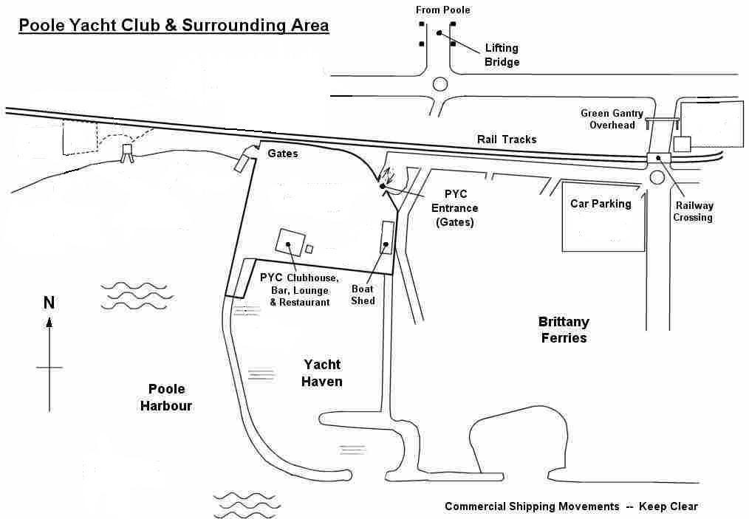

Addendum B – Race Area
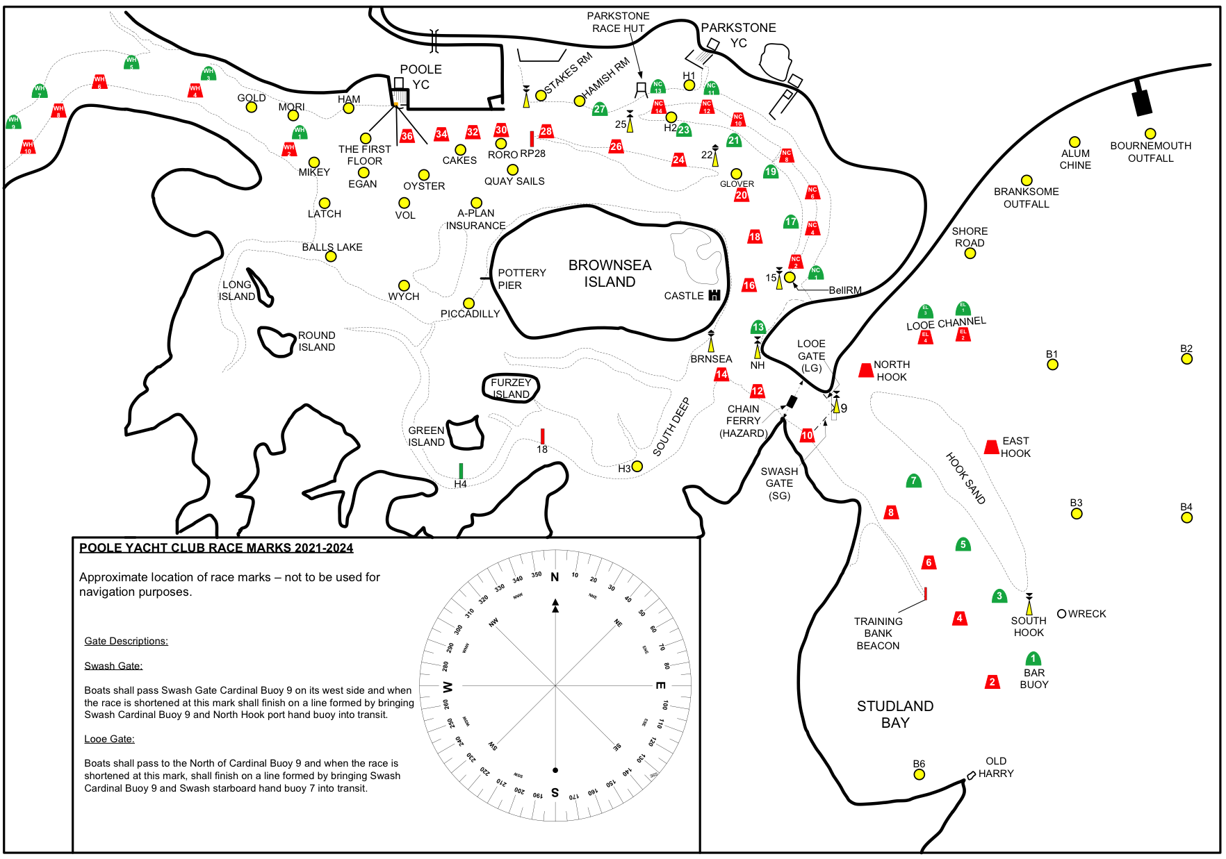
Expected Race Area

