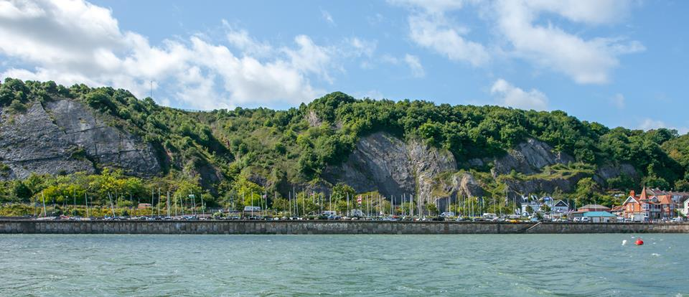

Merlin Rocket Silver Tiller and Fireball Open
19th to 20th July 2021
Mumbles Yacht Club, Swansea

NOTICE OF RACE
The Organizing Authority for the meeting is Mumbles Yacht Club and the Merlin Rocket Owners Association.
- Rules
  - The event is governed by the rules as defined in The Racing Rules of Sailing 2021-2024, the rules of the Merlin Rocket Owners Association and this Notice of Race, except if any of these are changed by the Sailing Instructions.
  - The Event and any related social activity surrounding it, will be run under local government covid rules and guidelines. These will have presidency over NOR and SI’s.
- Sailing Instructions
  - The Sailing Instructions will be available after 20:00 on 18th July 2021 online linked from the event website at http://www.mumblesyachtclub.co.uk/admin/?page_id=4001
- Communication
  - The online Official Notice is located at http://www.mumblesyachtclub.co.uk/admin/?page_id=3983
  - While racing, except in an emergency, a boat shall not make voice or data transmissions and shall not receive voice or data communication that is not available to all boats.
- Eligibility and Entry
  - The event is open to all boats of the Merlin Rocket and Fireball classes.
  - Boats may enter the event by registering online at https://forms.office.com/r/nTax8zX5Cs
  - To be considered an entry in the event, a boat shall complete all registration requirements and pay all fees.
  - The following restrictions on the number of boats apply: There is to be a maximum of 35 boats across the event.
  - Should the event be cancelled for Covid related reasons or should a competitor have tested positive prior to the event and be unable to attend, a full refund of entry fees will be provided.
  - All Entrants may be asked to take a covid test on registration. Failure of this test or refusal to take it may result in the organizing committee refusing entry to the event. Should entry be refused on Covid 19 grounds prior to the first race, any entry fee, less an admin fee, will be returned.
  - All entrants will be required to confirm that they are, and have been for the previous 10 days, complying with all relevant Government Guidelines regarding Covid 19 in both their home nation and any separate requirements imposed by Welsh authorities. All Entrants will be expected to continue complying with all relevant Government Guidelines during the event.
- Fees
  - Entry fees (including a complementary meal or buffet and live music on Saturday evening) are as follows
Class | Early Entry Fee  until 23:59 Sunday 12th July 2021 | Standard Fee
Merlin Rocket Silver Tiller  Fireball | £45 | £50

- Crew Limitations
  - Class rules apply.
- Advertising
  - Boats may be required to display advertising chosen and supplied by the organizing authority.
- Qualification series and final series
  - This does not apply
- Schedule
  - Registration: There is no registration process, and no event documentation will be issued during the event. All race documentation will be available online.
  - Equipment inspection and event measurement: There is no scheduled equipment inspection or event measurement.
  - The number of races scheduled is 9. The intention is to run 3 races a day, however the Race Committee may amend this as they see fit. All times below are ‘not before’.
Day | Start Time | Warning Signal | Number of races | High Water
Saturday 17th July | 1200hrs | 1155hrs | 3 | 1214hrs 8.06m
Sunday 18th July | 1130hrs | 1125hrs | 3 | 1314hrs 7.85m

  - Following 2 races as soon as possible.
  - On the last scheduled day of racing no warning signal will be made after 1430hrs
- Equipment Inspection
  - Each boat may be required to produce or verify the existence of a valid measurement certificate.
  - Inspection or measurement may take place at any time except when racing.
- Clothing and equipment
  - RRS 40.1 always applies whilst afloat.
- Venue
  - The Event Venue is Mumbles Yacht Club.
  - An event plan showing boat and car parking is included as Addendum 1.
  - Racing will usually be in the confines of Swansea Bay.
- Courses
  - The courses sailed will be Triangle / Sausage / Triangle or Windward-Leeward.
  - The course target times are 40 minutes.
  - The courses will be 3 laps. Note that each sausage or triangle is counted as one lap.
- Penalty System
  - RRS 44.1 is changed so that the Two-Turns Penalty is replaced by the One-Turn Penalty.
- Scoring
    - When fewer than four races have been completed, a boat’s series score will be the total of her races scores.
    - When four or more races have been completed, a boats series score will be the total of her race scores excluding her worst score.
  - RRS 90.3e shall apply.
- Support person vessels
  - Support vessels shall not be allowed.
17, 18, 19, 20 DO NOT APPLY

- dATA pROTECTION
  - Mumbles Yacht Club has a data protection policy.
- Risk Statement
  - RRS 3 states: ‘The responsibility for a boat’s decision to participate in a race or to continue to race is hers alone.’ By participating in this event each competitor agrees and acknowledges that sailing is a potentially dangerous activity with inherent risks. These risks include strong winds and rough seas, sudden changes in weather, failure of equipment, boat handling errors, poor seamanship by other boats, loss of balance on an unstable platform and fatigue resulting in increased risk of injury. Inherent in the sport of sailing is the risk of permanent, catastrophic injury or death by drowning, trauma, hypothermia or other causes.
- Insurance
  - Each participating boat shall be insured with valid third-party liability insurance with a minimum cover of £2,000,000 per incident or the equivalent.
- Prizes
  - Prizes will be given to the top 3 of each class.
- Further Information
  - COVID-19 information
The changing rooms and showers are expected to be open at a limited capacity of 6 per changing room using a tally system and 2 showers operational in each changing room.
  - Social Activities
Any social activity linked to the event will be in line with local government Covid guidelines. The social side of the event will be updated nearer the event, however the club does have an open air roof top terrace and access to other exterior areas, plus a fair sized indoor area. It is hoped that limited social activity along the lines of a complimentary buffet on Saturday and live music will be able to take place.
  - Photography
We hope to have a photographer at the event to take and share photographs of the event.
  - Accommodation
There are a number of bed and breakfasts and air B & B’s within Mumbles and the surrounding area.
The Chapel House is offering event discount. Private rooms, dorms and private hire for up to 21 guests. This is in walking distance of the clubhouse.
Camper vans are allowed in the main car park by the clubhouse and boat park on a pay and display basis, and there is a larger car park within walking distance at Bracelet Bay.
There is no camping and no overnight toilet facilities.

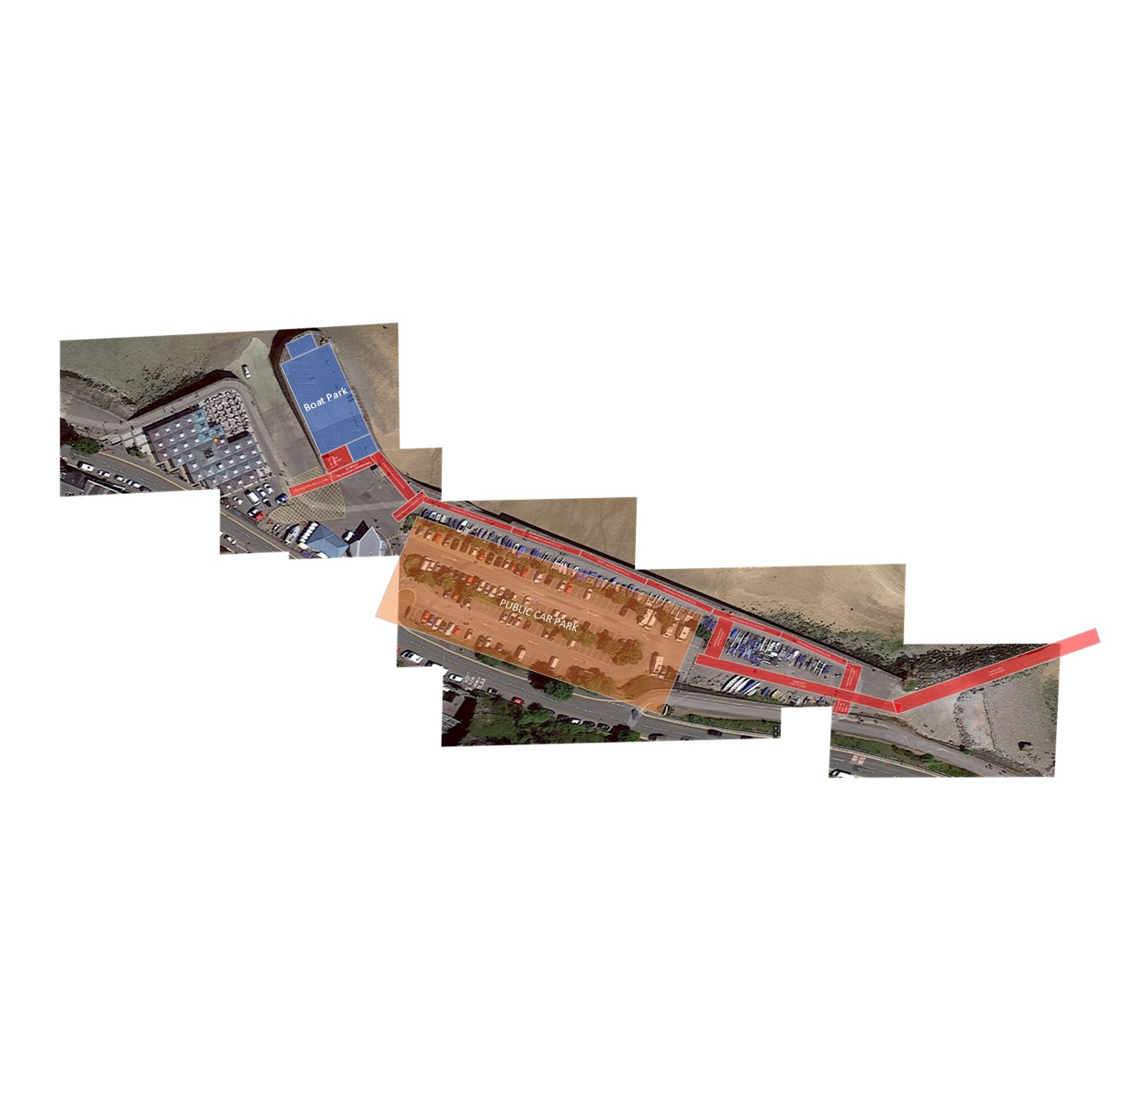
Addendum 1. Event map.

